Hometown Fitness Gym Program Portal Instruction

- Log on to www.HometownHealth.com and click on the Healthy Tracks link.

- Click on the Gym Benefit link.

- Click on the Gym Owners Enter Here box.

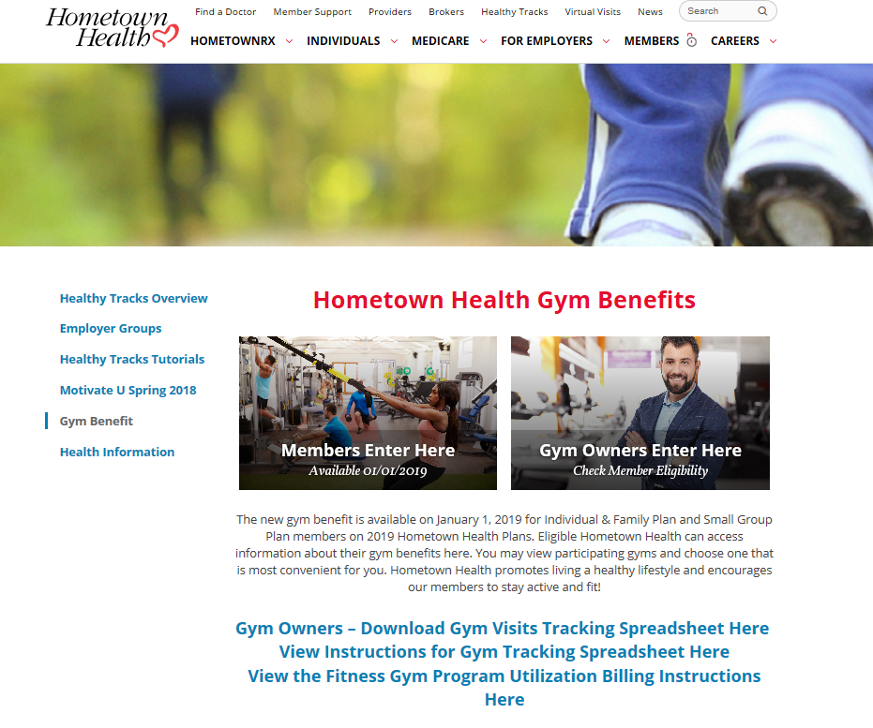

- Click on Check Gym Eligibility to view member’s eligibility for program.

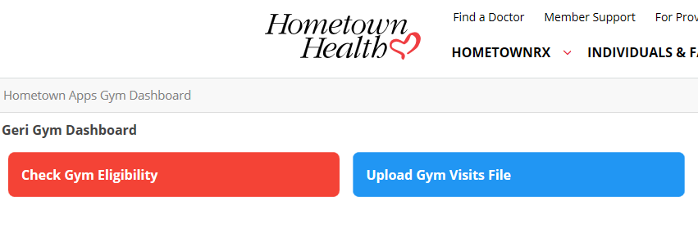

- Enter Member Number from member’s Hometown Health Identification Card (number should be 10 digits), and Click Submit.
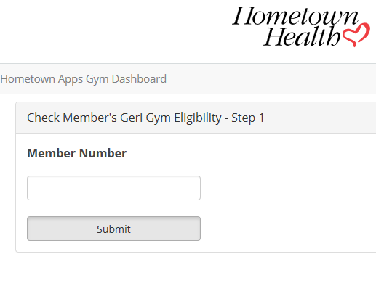

- Enter Member’s Date of Birth and Click Submit.
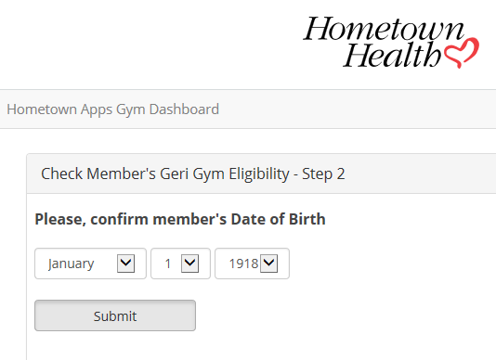

- Message will appear, confirming that your client/member is eligible for the Hometown Fitness Gym Program.

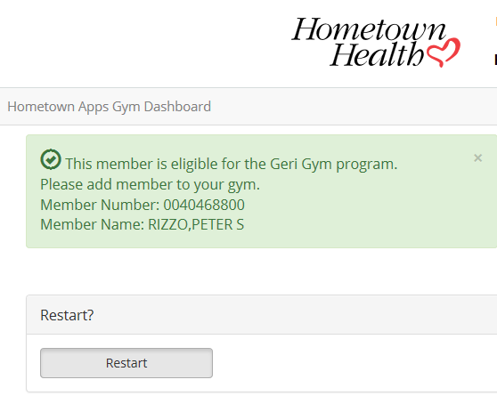\
Member’s Number and Name will be displayed in this area

- Click on Restart to check another member’s eligibility

Should you have any problems locating a member’s record or eligibility, please contact Customer Service, using the telephone numbers below:

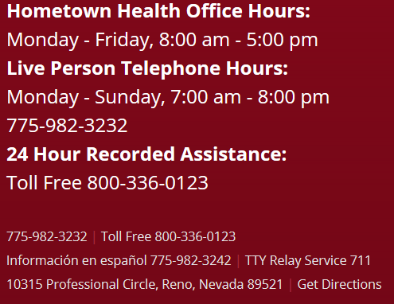

Hometown Fitness Gym Program Uploading Gym Visit Tracking Sheet

- Log on to www.HometownHealth.com and click on the Healthy Tracks link.

- Click on the Gym Benefit link.

- Click on the Gym Owners Enter Here box.

- If you have not already done so, download the Gym Visits Tracking Sheet by clicking on the link shown below

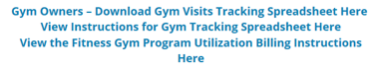

- Save this Excel spreadsheet document to your computer to track and submit member visits to Hometown Health for membership reimbursement. See instructions below regarding uploading tracking sheet to Hometown Health via GlobalScape site.

Hometown Fitness Gym Program Uploading Member Utilization

- Log on to www.HometownHealth.com and click on the Healthy Tracks link.

- Click on the Gym Benefit link.

- Click on the Gym Owners Enter Here box.

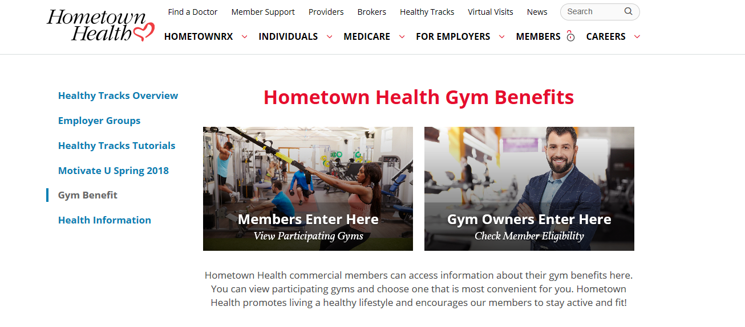

- Click on Upload Gym Visits File to upload your completed utilization spreadsheet for program. This must be completed in order for you to receive payment from Hometown Health for your members.

- The Globalscape site will open. You will need your Username and password, which will be supplied to you in a separate email from Hometown Health. Please note that if you have more than one location, you will need to upload a separate file for each, using the login information for the specific location.

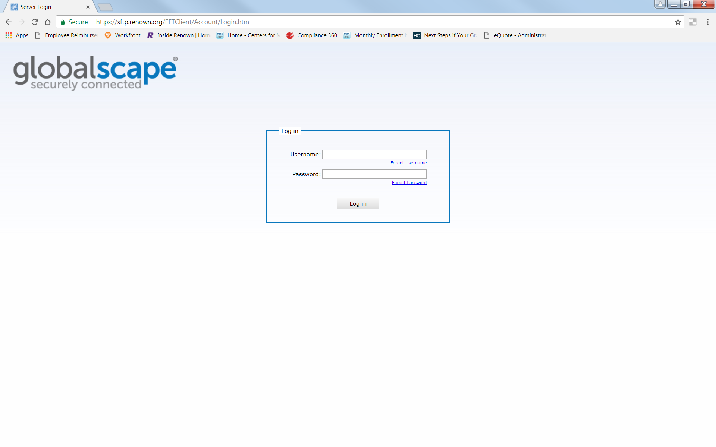
- Double click on the Inbound folder

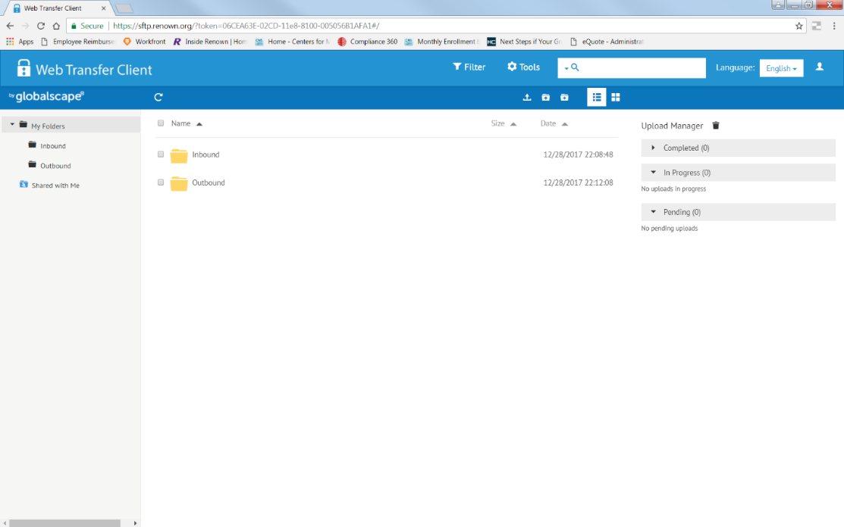

- Upload your completed Excel template here. You may drag and drop the file in the space or you may use the upload button as shown. When the file is uploaded it will be displayed on the screen with a check box next to it.

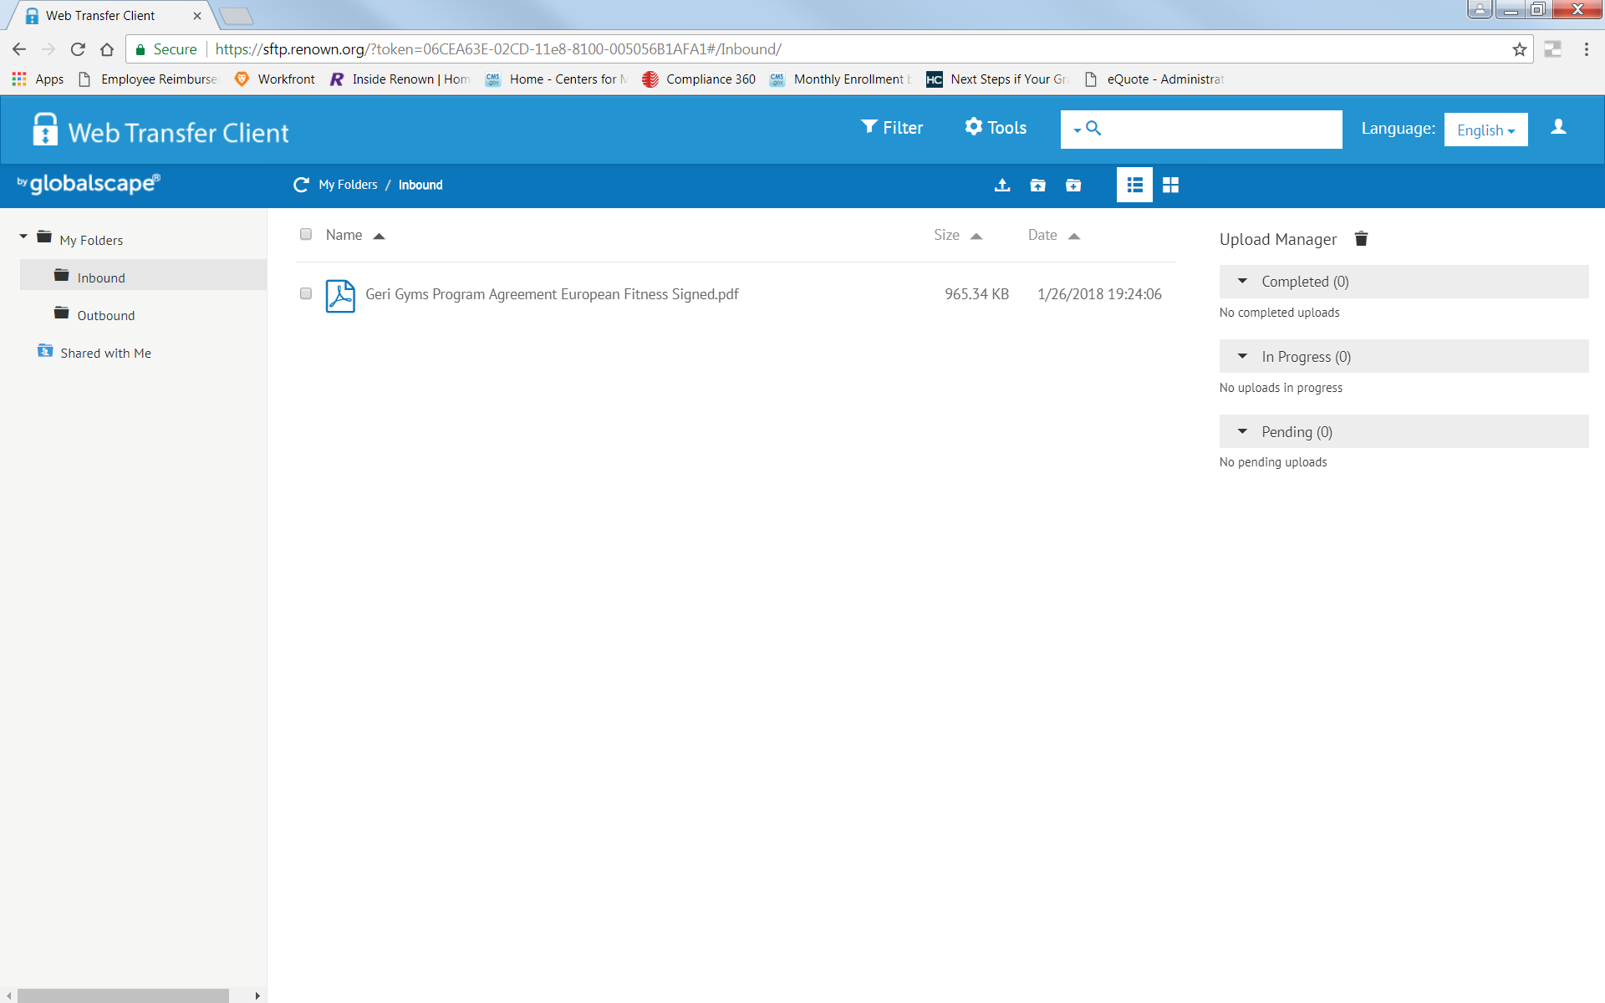

- Click on the icon shown below to log out.
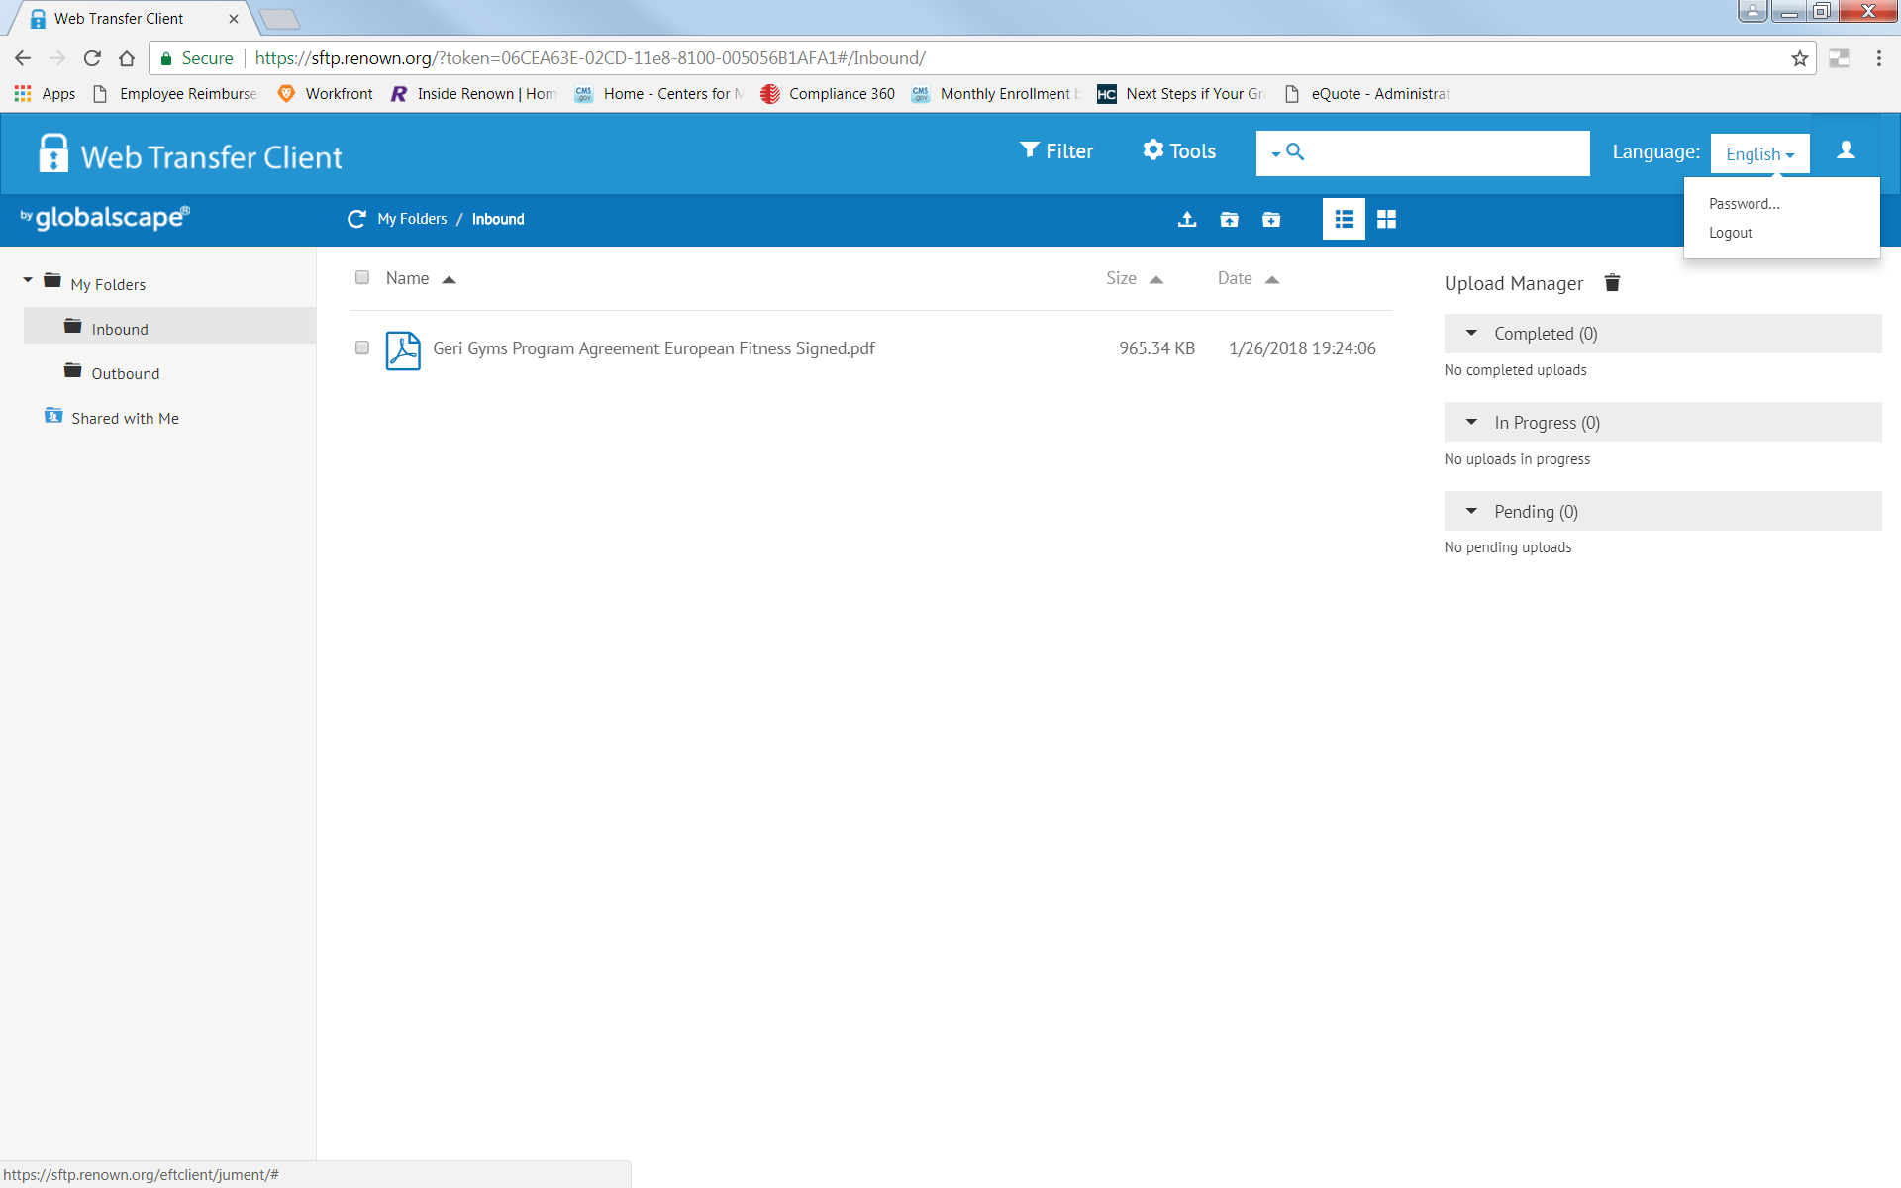
Instructions for completing the Hometown Fitness Gym Program Billing Spreadsheet
- Please use only the supplied Electronic Excel file (Downloaded from the website as instructed above) to bill Hometown Health for the monthly utilization for the Hometown Fitness Gym Program.
- Please make sure that you complete a SEPARATE spreadsheet for each location you own and upload the spreadsheet to the correct account on our FTP site. Please see uploading instructions for further information. ALL locations have a separate login for the FTP site, even if there is common ownership between locations. It is important to get the correct member billing listed under the correct entity or you may encounter problems for the next billing.
- Please list the Hometown Health or Senior Care Plus member identification number for each member you are submitting a bill for, as well as the date(s) of each visit to your location.
- Use only the Hometown Health or Senior Care Plus member numbers from the member’s identification card. We will not be able to process the billing if the 10-digit number is not listed or is incorrect. If you have any other questions or concerns please call (775) 982-3093 or email bgrace-smith@hometownhealth.com.

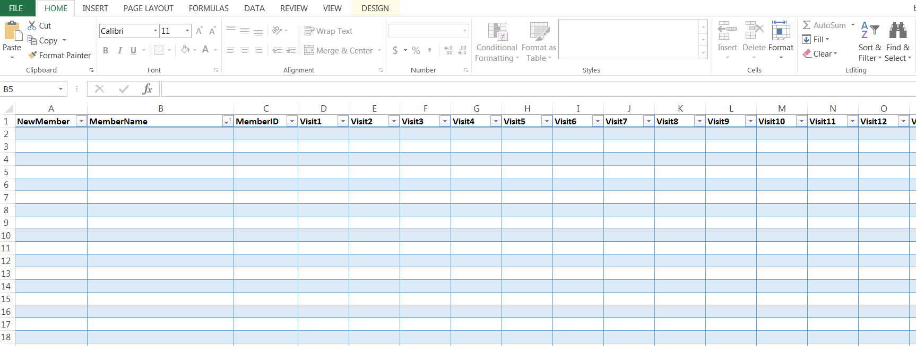

Best Practices and Troubleshooting
- Download Excel file, Gym Visit Tracking Document, from the Hometown Health website (see instructions included). This will open as an Excel file for your convenience.
- Spreadsheet has 33 columns, consisting of:
  - Member’s Name (Optional) (first column)
  - Member’s Identification Number (second column)
  - 31 Date-Ready columns to enter each member’s visit date throughout the logged month. Each date must be entered into a separate column. Duplicate dates will be ignored.
- Dates must be entered as MM/DD/YYYY. If this format is not followed, the download may be inaccurate and visits may be missed.
- Blank spaces, commas, or other characters can cause errors during the load process.
- DO NOT ADD OR REMOVE ROWS OR COLUMNS. This can cause the file to error out, which can delay your membership payment from Hometown Health.

Should you need further assistance, please feel free to reach out to me. I have also included our business information below.
