Link New Site Request

In order to gain access to Link, Hometown Health’s Employer Group Portal, you will need to Request a New Account. Our IT team will confirm your employer group coverage with Hometown Health.
YOU WILL RECEIVE AN EMAIL CONFIRMATION WITH YOUR USER ID AND TEMPORARY PASSWORD WITH A LINK.
Your account will be available to you effective January 1, 2022.

It’s important to note, users that are requesting the site will be considered the Site Administrator. Once the site is active on January 1, 2022 and thereafter, the Site Administrator will be able to grant access to other users within their office or broker partners, if so delegated.

Requesting an Account
- The Site Administrator will go to the EpicCare Link https://ecl.renown.org and select “Request New Account”.
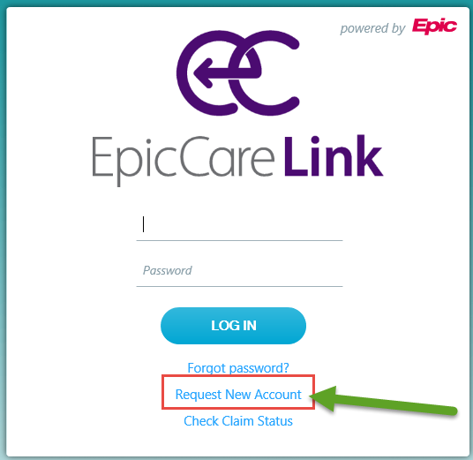

- In the “New Account Request” section, click on “Request access for a new non-clinical service account”.

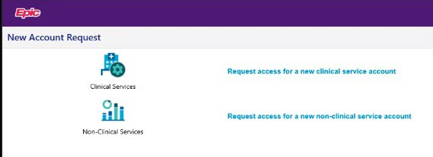

- Complete the Site Information, Entering your business/organization name as Site Name and Selecting “Employer” as your Site Type.
Indicates required fields in this application.

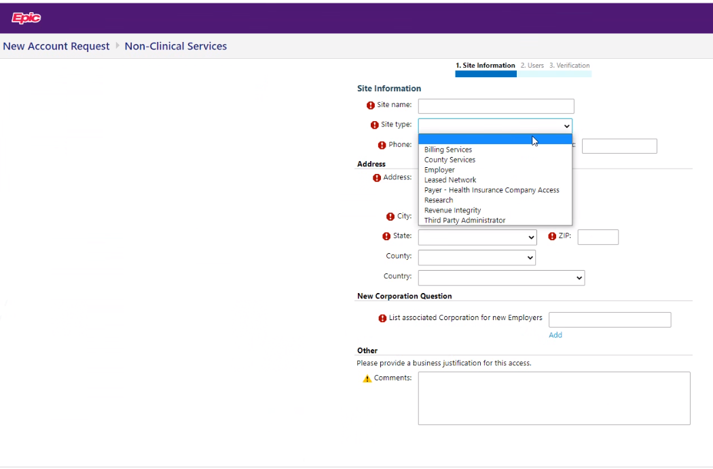
Select Employer

  - For New Corporation Question, you would add any other businesses associated with your organization.
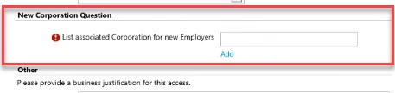

- Next, from the New Account Request section, you’ll need to click the link “Request a New Site Admin”. This should be a delegated benefits administrator or HR representative who would have access to add or remove contacts who have access to your employer group portal.

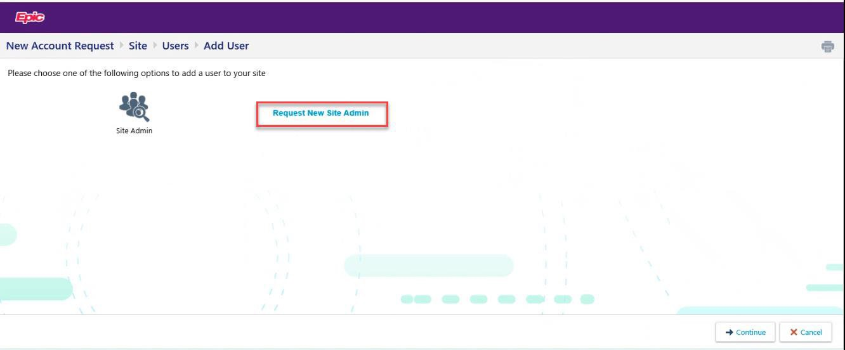

- Make sure the information is correct and click “Accept” to continue.

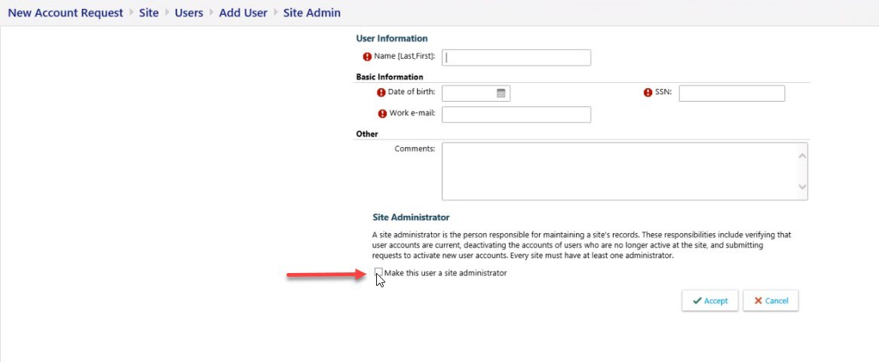

- Review & confirm your information by selecting “Verification” on the next screen.

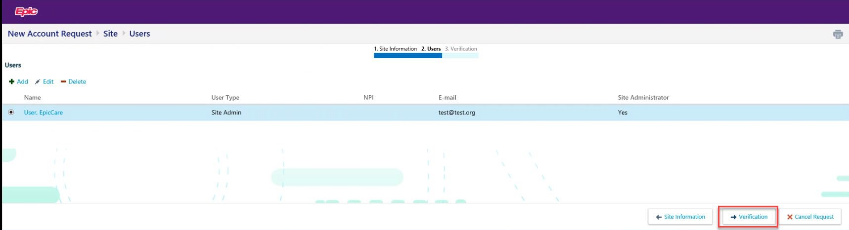

- Review and Agree to the terms and conditions, checking the box for “I’m not a robot”. Complete the verification reCAPTCHA process and enter your name in the “Requested By” field.

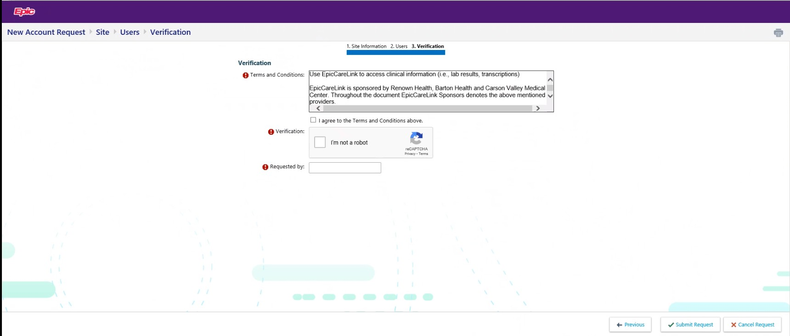

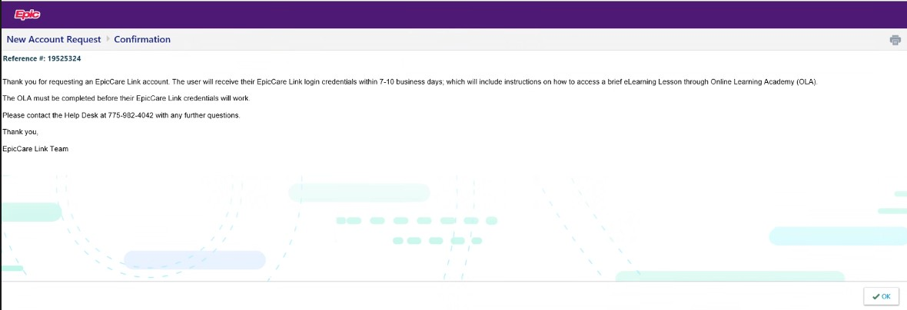
- Site Administrator will get a confirmation with a Reference number when request is complete.
For questions regarding registration, please reach out to the Help Desk 775-982-4042.

